**Assignment 2**

1. **Relational Modeling**
   1. **Download**[**Sakila dataset**](https://canvas.uchicago.edu/courses/16341/files/1565208/download?verifier=u1mmxIgdOvNSOJh34dvbbr4U39hPWzxv1gi2iYTZ&wrap=1)**and unzip**[**sakila-db.zip**](https://canvas.uchicago.edu/courses/16341/files/1565203/download?verifier=FcRsvQz31eRCRrABkrqJN2YkdPjjlgdEV0zHTKGf&wrap=1)**file**

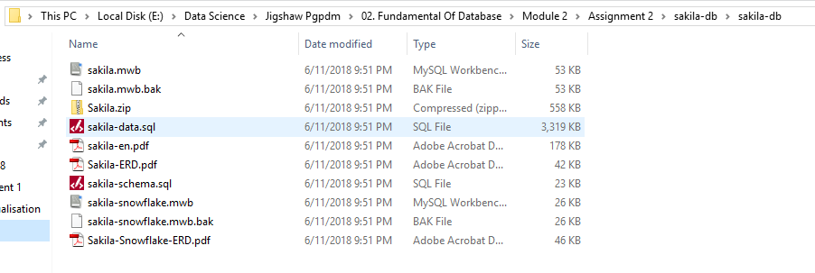

* 1. **Open MySQL workbench and execute the**[**sakila-schema.sql**](https://canvas.uchicago.edu/courses/16341/files/1565150/download?verifier=NM5RBDuX6ZbeUqLwkVSnzayWpA9y0SjyeZKk0Xd7&wrap=1)**script**

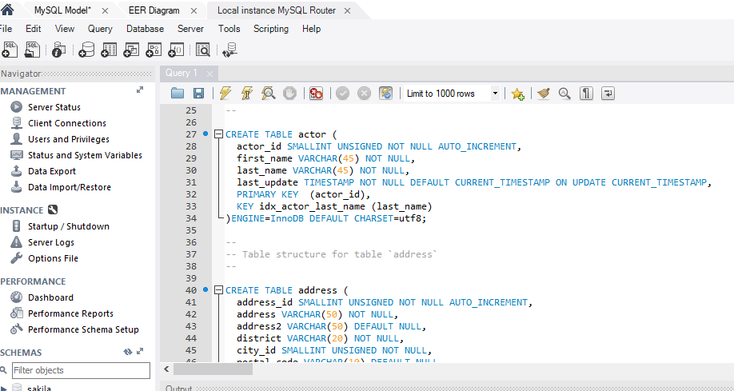

* 1. **Reverse Engineer the database and generate the EER model**

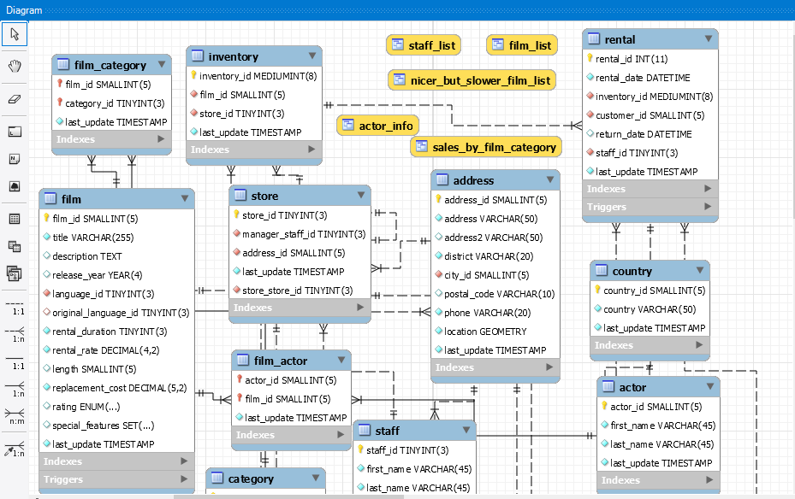

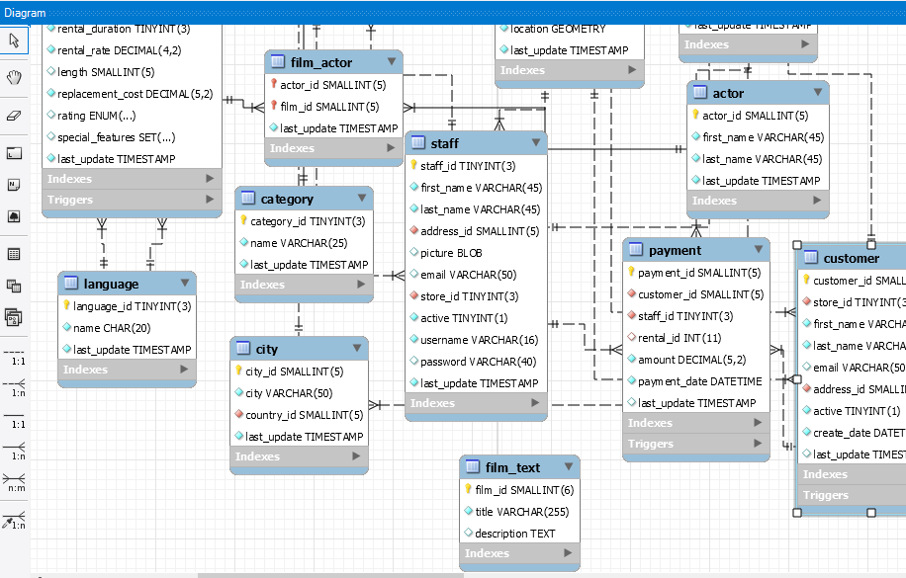

* 1. **Modify the EER model to add a new lookup table :**
     1. **payment_type which has a 1 to Many relationship with the Payment table with attributes:**
        + **payment_type_id (Primary Key) : SMALLINT(6)**
        + **method - varchar (10)**
        + **description – varchar (45)**

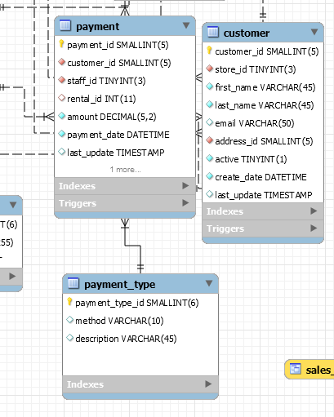

* + 1. **Add payment_type_id as a foreign key in the Payment table as follows:**
       - **Payment_type_id (Foreign Key) : SMALLINT(6)**

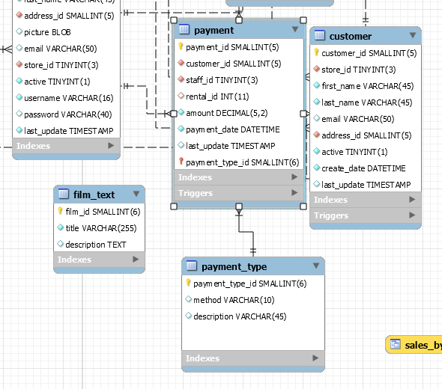

* 1. **For the Payment table fill out the form below:  
         Table Name: Payment**

|  |  |  |  |
| --- | --- | --- | --- |
| **Field (Attributes)** | **Primary (Y/N)** | **Foreign Key (Y/N)** | **Related Table(S) and cardinality between tables (tables to Payment)** |
| payment_id | Y | N |  |
| customer_id | N | Y | Table=Customer, Cardinality=1:n |
| staff_id | N | Y | Table=Staff, Cardinality=1:n |
| rental_id | N | Y | Table=Rental, Cardinality=1:n |
| amount | N | N |  |
| payment_date | N | N |  |
| last_update | N | N |  |
| payment_type_id | N | Y | Table=Payment_type, Cardinality=1:n |

1. **For the Sakila dataset, provide the relational algebra syntax (only) for the following queries :**
   1. **List all payments greater than and equal to 2$ and less than equal to 7$**

Ans. $σ(amount≥2 ^ amount≤7)$ (payment)

* 1. **List all the movies with title and description that are rated PG-13**

Ans.

* 1. **Replace the word “film” with “movie” for all attributes and relations starting with the word “film”**

Ans.

* 1. **List all customer names who have returned their rentals in the current month**

**Ans. $π (first_name,Last_name)(customer ⋈month\left(rental,rental_date\right)= month\left(rental,rental_date\right) (Rental))$**

1. **Normalization**
   1. **For the table below, provide examples of insertion, deletion, and modification anomalies.**

Ans. Patient Jill bell has transferred to new address. To make data consistenty, update statment needs to be written multiple times

Insert Anmomoly.

A patient needs skin grafting done but he has not taken appointment. In order to keep the record,null has to be entered.

Deleted Anomoly

If a record is deleted then information about doctor is also deleted.